Notes - Linear Optimization Day 2 Name_________________________________

Senior MATH Hr_________

Learning Targets:

* Use linear optimization/programming to solve applications.
* Recognize situations in which there are no solutions or more than one solution of a linear programming application.

Warm Up:

1. 



2. 

Ex 1.

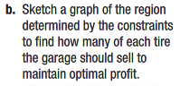

Ex 2.

