Notes - Linear Optimization Day 1 Name_________________________________

Senior Math Hr_________

Learning Targets:

* Use linear optimization/programming to solve applications.
* Recognize situations in which there are no solutions or more than one solution of a linear programming application.

Why? Business Constraint Resource:

 <http://www.ehow.com/info_8366449_business-constraint.html>

Name some factors to consider when choosing business constraints:

Why is it important to consider business constraints?

Optimization-

Linear programming-

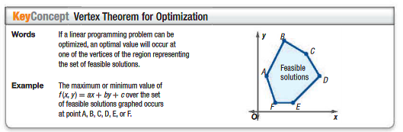

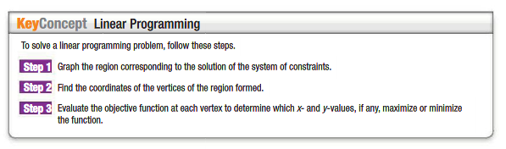

Ex 1.

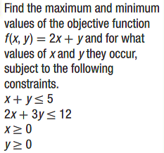

Ex 2.

