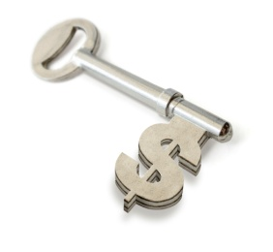More Investing Scenarios Name___________________________________________

*Senior Math Applications*

The key to making more **MOOLA** in investing.

The exponential equation  can be used to calculate the yield of an investment that is compounded: annually, semiannually, quarterly, monthly, weekly, daily, hourly, or every minute.

*Same as the second formula in the Tim and Tom Activity. We just had 1 for n for that scenario.*

The components:

A ~ The value of the investment in the future P ~ The original investment

r ~ The interest rate t ~ The number of years for the investment

n ~ The number of times the interest in compounded each year

1. How much money will you have if you invest $4000 in a bank for sixty years at an annual interest rate of 9%, compounded monthly?

2. You put $1 million dollars in the bank for two years at an interest rate of 20%. How much money will you have total after the two years if the bank calculates and compounds the interest daily?

3. How long would it take to triple an investment of $5000 at 8% interest compounded semiannually?

4. Assuming that the bank calculates and compounds the interest quarterly, what interest rate is needed to turn $100 into $2250 in thirteen years?

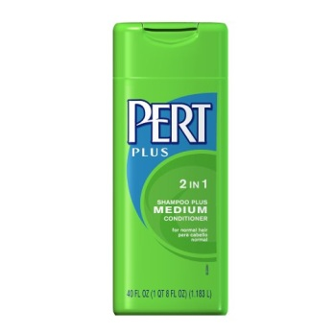It doesn’t take an “**e**instein” to figure out there is a whole lot of “**e**” going on!

**e** is not only a famous #, but it is also has special uses in formula’s and logarithms!

Use the formula:  to determine the balance of an account where the money is **compounded continuously**.

***\*Continuous compounding is done around the clock\****

5. Laura sold an antique stuffed bear for $2000. She decides to invest the money in a bank account until she retires in 25 years.

a. Find the amount that she will earn in a bank account that pays 5.25% interest compounded continuously.

b. Find the amount she will earn in a bank account that adds $10 to the initial deposit for new accounts, and pays 5.25% interest compounded quarterly.

c. Should she invest in the account with continuous compounding or the one with quarterly compounding? Why?

6. The Romeo Boosters club decided to invest a portion of their funding for the future Bulldogs. Suppose the invest $1500 at 5.8% compounded continuously.

a.) In 10 years, when the booster clubs needs b.) When will the investment be doubled?

this money, how much will be available?

7. Daisy has $250 to invest at 10% interest compounded continuously. How much money will Daisy have in her account in five years?