Senior Math Name: _____________________________Hr.______
Final Exam Mini Review #1

Use the following scenario for question #1-5.
You want to start your own hedge trimming company. You investigate what you need and find out that you need to purchase a rake for $25, a power hedger for $105 and a blower for $90. You also determine that it will cost an additional $1.25 for gas for each job. You decide to charge $30 per job.

1. What is the cost rule?

2. What is the revenue rule?

3. What is the profit rule?

4. Graph cost, revenue, and profit below.

5. How many jobs would you have to complete to break even and start making money?

Use the following scenario for question #6-10.
Scenario: A hot dog vender has studied his cost “C(x)” and revenue “R(x)” across the course of the month. The cost and revenue depend upon the number of hot dogs he sells. The following algebraic rules represent the two relationships where x represents the number of hot dogs made/sold, and the cost and revenue measured in dollars.
$C\left(x\right)=0.50x+800$ $R\left(x\right)=2.25x$

6. List what you know about the cost based upon the given cost equation.

7. List what you know about the revenue based upon the given revenue equation.

8. What would be his profit rule?

9. How many hot dogs would he have sell to start making a profit?

10. What would happen to the break-even point if he decided to charge $2.00 per hot dog?

Senior Math Name: _____________________________Hr.______
Final Exam Mini Review #2

For question #1-4, use the following scenario.
The amount of time a group of people spend watching tv each night is given (hours).
1.6, 0.2, 3.7, 4.2, 3.6, 1.9, 2.0, 0.9, 3.3, 5.9, 4.1, 1.0, 0.5, 3.2, 1.2

1. Identify the mean of the data set.

2. Identify the median of the data set.

3. Identify the mode of the data set.

4. Identify the range of the data set.

Use the box-and-whisker plot to answer question #5-7.
Time Spent Memorizing History Facts vs. History Test Scores

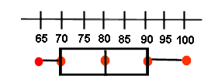
Test Scores

5. What percent of students scored between 70% and 100% on the test?

6. What is the 75th percentile?

7. What is the IQR (interquartile range)?
Sampling Methods: Random Sample, Convenience Sample, Stratified Random Sample, Cluster Sample, and Systematic Sample.

Use the following scenario to answer question #8-11.
The Mayor of Romeo wants to find out what Romeo Residents think about the parks in the city.

Determine what type of sampling method he is using in each example. Explain why after.

8. He surveys people that visit his office.

9. He calls every 30th citizen off a list of Romeo Residents.

10. He randomly surveys 100 male and 100 female residents.

11. He uses his computer to randomly generate a list of citizens to survey.

For question #12-13, use the scenario given to answer the questions.
You are trying to decide if younger people buy more candy than older people.

Determine whether the given study is an observational or experimental study.

12. You stand near the cash register in the convenience store and record the candy purchases of the customers along with their age status.

a. Observational b. Experimental

13. You set up a candy stand and record the age status of your customers when they buy candy from you.

a. Observational b. Experimental

Senior Math Name: _____________________________Hr.______
Final Exam Mini Review #3

For question #1-5, use the following scenario.
Amount of practice time for varsity lacrosse team per week (hours) vs. # of wins at the end of the season.
Amount of practice time/week | 10 | 8.5 | 14 | 6.5 | 12 | 13 | 7.5 | 18 | 9.5 | 7 | 6 | 11 | 8.5 | 8
# of wins | 11 | 5 | 13 | 7 | 12 | 15 | 10 | 16 | 12 | 9 | 2 | 9 | 11 | 5

1. Use your calculator to determine the equation of the line of best fit.

2. What does the slope mean in the context of this problem?

3. What does the y-intercept mean in the context of the problem?

4. How many wins would a you predict for a lacrosse team that practices 14 hours per day?

5. Is your prediction in question #24 an example of interpolation or extrapolation? Why?

6. Determine the strength and direction for the given scatterplot.
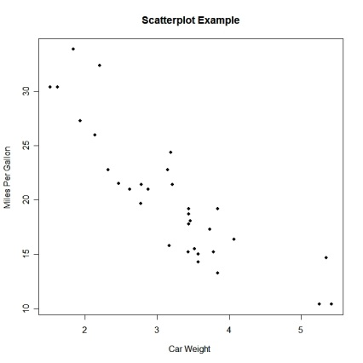
r= -0.82

7. For the scenario given below would you expect the variables to have a negative, positive, or no correlation?

- Number of strikes vs. number of hour practicing bowling

- Waist Size vs. IQ

- # of kids in family vs. amount of sleep for the parents

- Cash in wallet vs. number of hours working

- # of playoff wins for the Tigers vs. # of home playoff games

Senior Math Name: _____________________________Hr.______
Final Exam Mini Review #4

For question #1-5, use the following scenario.

The test scores for a recent Senior Math Quiz are approximately normal. The mean is 82% and the standard deviation is 5. Create the normal curve for this data below to help answer question #26 & 27.

1. What percent of the students scored above a 77%?

2. Of a group of 35 Senior Math students, how many of them scored between a 72% and a 82%?

3. Using your z-score formula and z-table, determine what percent of students would score below an 88% on the test.

4. Using your z-score formula and z-table, determine what percent of students would score above an 84% on the test.

5. Using your z-score formula and z-table, determine what percent of students would score in between a 74% and a 83%?

6. You are examining your last two tests. On the Test A you scored a 81%. The class mean for Test A was an 75% and the standard deviation was a 4.91. On Test B you scored a 76%. The class mean for this quiz was a 71% and the standard deviation was a 3.28. On which quiz did you do relatively better? Why?

Senior Math – Z-Scores Table and Probability Scenarios

When finding probabilities for normal distribution there are three scenarios:
- To find probability below a certain data value:
1. Get the z-score
2. Find the probability on the z-table
$$z=\frac{\left(x-\overline{x}\right)}{σ}$$
- To find the probability above a certain data value:
1. Get the z-score
2. Take: 100 - the probability you get on the z-table

- To find the probability in between two data values:
1. Find both z-scores
2. Get the probability for both on the z-table
3. Take: big probability – small probability
