Final exam review Part 1 Name_________________________

Trig, Prob, Stats

Algebra II Hour ___________ Date__________

For 1-3, identify the reference angle.

1. 
2. 
3. 



60o

45o





60o

5



30o



1. Find the six trigonometry ratios for  in standard position with on its terminal side.
2. Find the six trigonometry ratios for  in standard position with on its terminal side.
3. What is the coordinate on the terminal side for ?
4. What is the coordinate on the terminal side for ?
5. What is the coordinate on the terminal side for ?
6. List the six trig. ratios for .
7. Label all of the degree and radian measures, and coordinates on the outside of a unit circle.

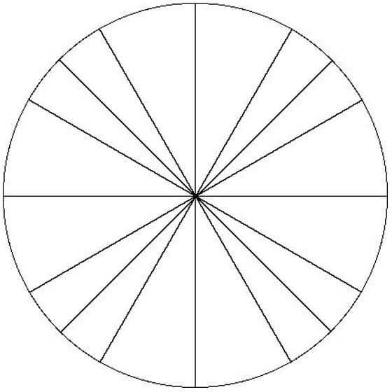

**Directions: Find all angles  and  for each of the following.**

1. 
2. 
3. undefined
4. 
5. 
6. 

21. Solve . Give your answers in both degrees and radians.

22. Solve . Give your answers in both degrees and radians.

1. Solve . Give your answers in both degrees and radians.
2. Solve . Give your answers in both degrees and radians.
3. What is the coordinate on the terminal side for ?
4. What is the coordinate on the terminal side for  ?

27. What is the coordinate on the terminal side for ?

1. List the 6 trig ratios for ?
2. What is the coordinate on the terminal side for ?

For #30-33, graph each function and **list intercepts (midline & y), domain, range, max(s) and min(s).**

1. 
2. 

32.  33. 

1. Graph the function and then answer the questions that follow. You will not be graded on your graph.

Amplitude =_______ Period =________________________________________________

Midline intercept(s)______________________Midline equation______________________

Y-intercept_____________________________Domain_____________Range______________

Maximum(s)____________________________Minimum(s)____________________________

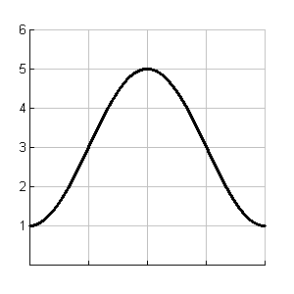Write the equation for the function that is graphed.

0

π

2π

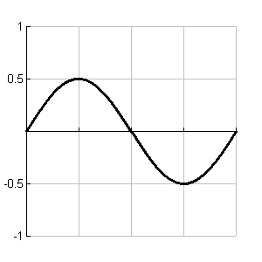

0

π

2

π

4

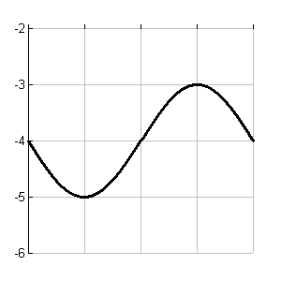

0

2π

3

π

3

1. Use the following data to answer the questions:

*3 10 12 13 15 16 16 17*

*18 19 19 19 20 20 25*

1. What is the mean of the data set?
2. What is the median of the data set?
3. What is the mode of the data set?
4. What is the lower/1st quartile?
5. What is the upper/3rd quartile?
6. What is the standard deviation?
7. What is the range?
8. Create a box plot for the data.
9. The following data has been found when studying the depths of different types of SCUBA equipment:

Lower Quartile: 12 m below sea level

Median: 32 m below sea level

Mean: 38 m below sea level

Mode: 30 m below sea level

Upper Quartile: 72 m below sea level

* 1. Based on the information, explain why you think the data will have a certain shape.
  2. Construct a box plot if the minimum and maximum depths are 1 m and 318 m below sea level.

1. Lorri is training for a marathon. The times of her practice runs form a normal distribution with  = 2 hr 33 min and  = 3.5 min.
2. Draw and label the approximately normal curve.
3. About 68% of her times fall within what times?
4. What percent of her times are between 2 hr 26 min and 2 hr 33 min?
5. In order to qualify for a certain marathon, a runner must have an official time of 2:40 or less in a previous race. Once Lorri chooses a qualifying race, what is the probability that she will qualify for the marathon?
6. Lorri ran a marathon in 2:50. She thinks this is not a good representation of her times. Would you agree? Why/why not?
7. It is possible to score higher than 800 on either part of the SAT, but scores above 800 are reported as 800. In 1999, the scores on the math part of the SAT followed a normal distribution with mean 531 and standard deviation 115. What percent of scores were above 800 (but still reported as 800)?
8. 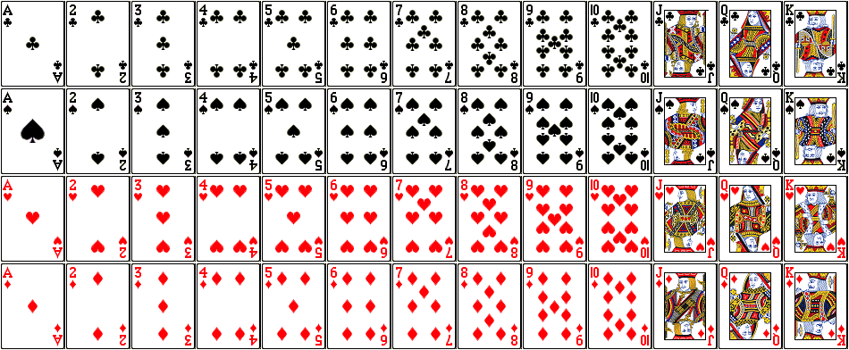Use a standard deck of playing cards to determine each of the following:
9. P(not a 9)
10. Odds in favor of selecting a spade
11. P(selecting a heart then a 6 (with replacement))
12. P(selecting a face card and then another face card (without replacement))
13. P(not having a 10)
14. The college Physical Education Department offered an Advanced First Aid course last semester. The scores on the comprehensive final exam were normally distributed, and the z-scores for some of the students are shown below:

Robert 1.10 Jan 1.70 Susan -2.00

Joel 0.00 John -0.80 Linda 1.60

1. Which of these students scored above the mean?
2. Which of these students scored at the mean?
3. If the mean score was = 150 with standard deviation  = 20, what was the final exam score for each student?
4. The box plot below shows the ages of actresses who have received an Oscar award for their performances.
5. 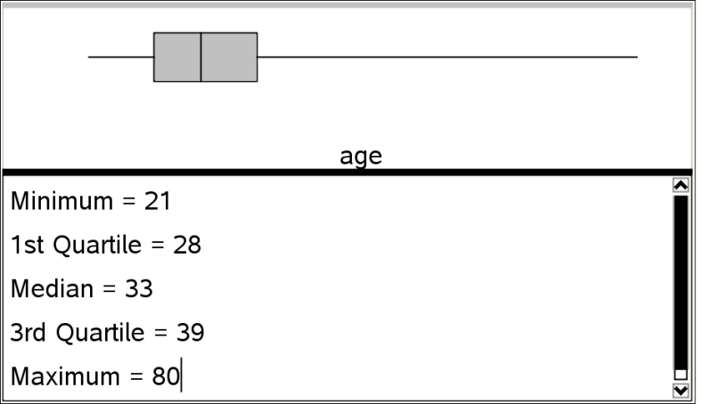At what percentile is an actress who is 28 years old?
6. If an actress is at the 50th percentile ranking, what is her age?
7. At what age would 75% of the actress be at that age or below?

45. Order the following from smallest to largest standard deviation:

Data Set A Data Set B Data Set C Data Set D

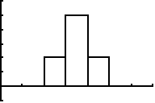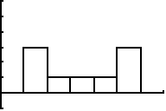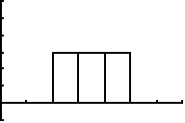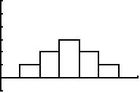

(Please write the letters in order from smallest to lowest)

46. The following data has been found when studying teenager text messages sent/received per day:

Minimum: 0

Lower Quartile: 305

Median: 386

Mean: 365

Mode: 409

Upper Quartile: 495

Maximum: 600

Can you conclude that there will be outliers? Show your reasoning.

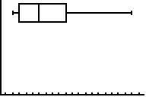

47. Use the following box plot to answer the questions below:

* 1. Label the mean and median on the graph.
  2. What is the shape of the graph?

Find the first four terms of the sequence described:

48.  49. 

Find the sum of the given series:

**Formulas**

an = a1 + (n – 1)d

Sn = n

an = a1 (r)n-1

Sn = a1

50. 

51. 

Find the specific term in the sequence.

52. in the sequence of 

53. 