Review – Stem-and-Leaf Plots + Box Plots Name_____________________________Hr_____
Directions: Be sure to include a detailed title and legend for your stem-and-leaf plots. Be sure to include a detailed title, label your five-number summary, and percentages for your box plots.
1. Samantha is trying to decide if she wants to attend a school in-state or out-of-state.

Please visit http://money.cnn.com/tools/collegecost/collegecost.html to get the data sets for the lines below in part a. (Search the exact names listed below in the “Enter School Name” search box.)
In-State Colleges: Wayne State University, Oakland University, Ferris State University, Eastern Michigan University, Michigan State University
Out-of-State Colleges: University of Florida, Florida State University, University of Georgia, University of South Carolina (Columbia), University of Alabama (Tuscaloosa)
a. In-State-Tuition Data: (Make sure you use: “In-State Tuition and not “Total Annual Cost”)
_________________________________________________________________________________________
Out-of-State Tuition Data: (Make sure you use: “Out-of-State Tuition and not “Total Annual Cost”)
_________________________________________________________________________________________
b. Determine the mean, median, and mode for the in-state and out-of-state tuition costs.
In-State Tuition _________________ Out-of-State Tuition _________________
In-State Tuition M _________________ Out-of-State Tuition M__________________
In-State Tuition Mode_______________ Out-of-State Tuition Mode_______________
c. List the 5-number summary for the out-of-state and in-state tuition costs.
In-State _________________________________ Out-of-State _________________________________
d. Create a box plot for the data, and then answer the following questions.

e. 75% of the In-State tuition costs are above what dollar amount?________
f. Explain what the 50th percentile of the Out-of-State box plot tells you?
2. Using the outlier rule determine if an outlier exists in the data set given below.
Free Throw Shooting Percentages for the 2014-15 Detroit Pistons:
Greg Monroe, PF | 0.74
Brandon Jennings, PG | 0.84
Reggie Jackson, PG† | 0.95
Andre Drummond, C | 0.39
Kentavious Caldwell-Pope, SG | 0.69
Jodie Meeks, SG | 0.92
D.J. Augustin, PG† | 0.87
Kyle Singler, SF† | 0.81
Anthony Tolliver, PF† | 0.80
Tayshaun Prince, SF† | 0.69
3. Create an ordered side-by-side stem and leaf plot for the data given below.
Ages of customers in a movie theatre seeing Paddington:
3, 9, 34, 12, 4, 40, 16, 6, 9, 5, 29, 33, 9, 22, 3, 11, 10, 45, 12, 64, 5, 8
Ages of customers in a movie theatre seeing American Sniper:
45, 18, 24, 19, 34, 29, 15, 18, 72, 40, 37, 22, 17, 48, 25, 20, 44, 52, 16, 71, 19

4. Create an ordered stem-and-leaf plots to display the data given below, grouped by 5’s.
# of Big Ten Football Championships per School
Illinois | 15
Indiana | 2
Iowa | 11
Maryland | 0
Michigan | 42
Michigan State | 8
Minnesota | 18
Nebraska | 0
Northwestern | 8
Ohio State | 35
Penn State | 3
Purdue | 8
Rutgers | 0
Wisconsin | 14

5. The box plot given below represents the waiting time at Olive Garden on a Saturday night. Analyze the box plot by the questions that follow.
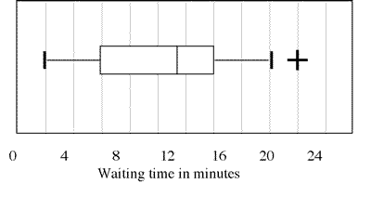
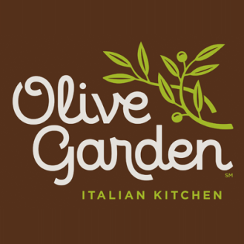

0 6 12 18 24 30
Wait Time for OG Customers

a. What percent of customers will wait less than 9 minutes?

b. What is the shortest wait time?

c. Suppose 591 customers visit the Olive Garden that night. Of these customers, how many would wait more than 21 minutes?

d. What does the “+” symbol denote?

e. If you have been to Olive Garden, what is your favorite meal?

